**EXT1100 SWING**

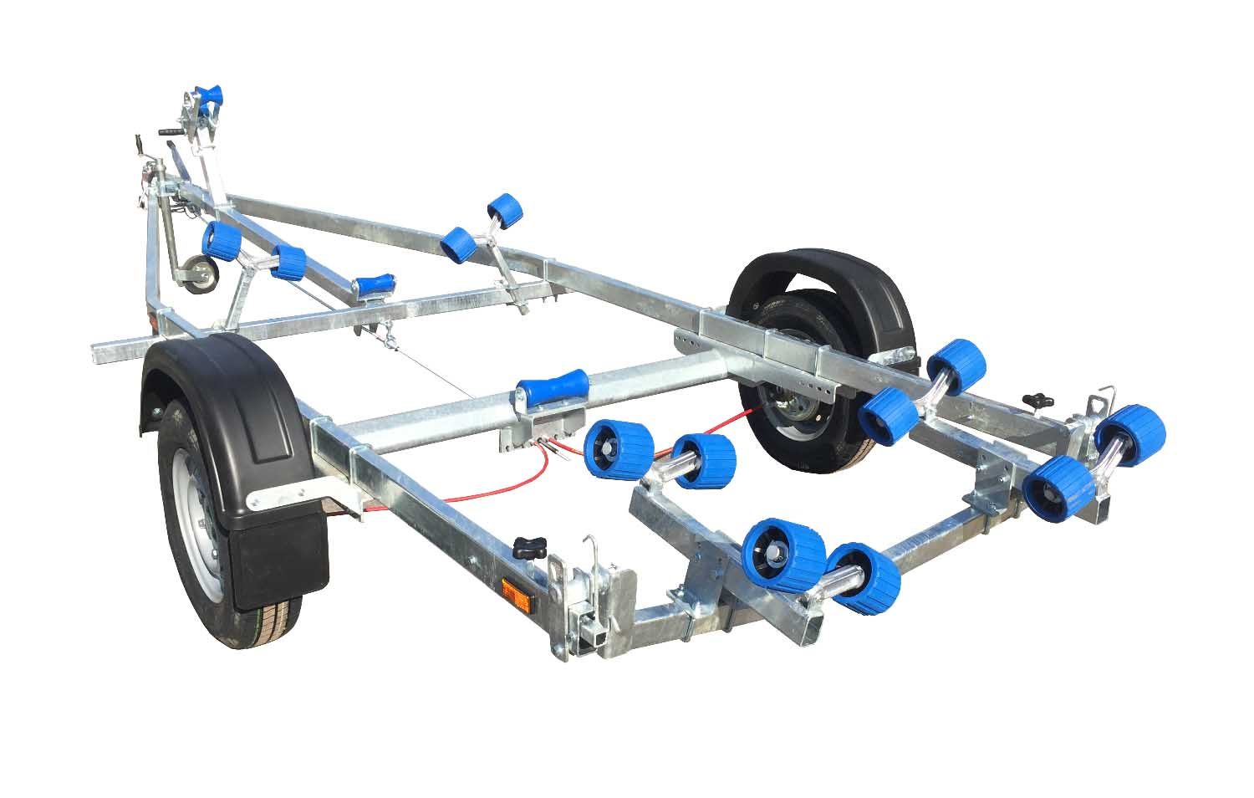

**BRAND NEW EXT1100 SWING GALVANISED BOAT TRAILER.**

Suitable for dinghies up to 19’ (with overhang), 16’ hard boat and 5.2m rib.

With a trailer weight of 280kg it can take 820kg of boat weight.

Designed and manufactured in the UK.

Standard features include:

Heavy duty frame

AL-KO axle

Waterproof sealed bearings

Adjustable swinging arm

12 nylon non marking wobble rollers

2 heavy duty keel rollers

Heavy duty height adjustable winch post

165R13 wheels

42mm jockey wheel

1400lb Dutton Lainson winch

Light board on extendable arms

Everything on this trailer is adjustable, so it can fit most hull shapes.

Overall length: 5.45m

Overall width:  2.05m

RRP: £2194